GRTC to celebrate launch of Route 1 service to Virginia Center Commons
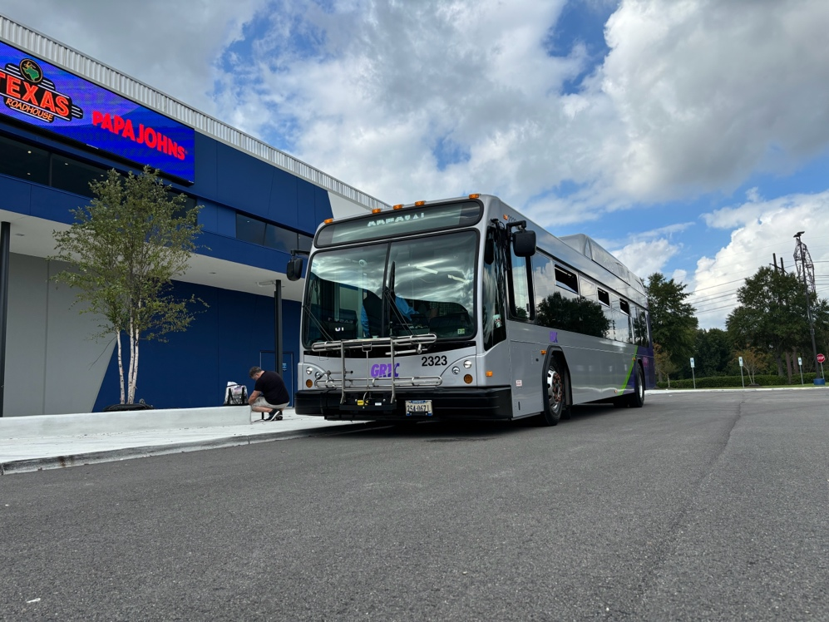
Henrico – On Monday, October 21, GRTC will host a ribbon-cutting to celebrate the launch of Route 1 service to Virginia Center Commons. The ribbon cutting will be held at 3 pm at the Henrico Sports and Events Complex (1 All Star Boulevard, Glenn Allen, VA) and will feature remarks followed by the ribbon cutting and a small reception.
The new, extended Route 1 connects Downtown Richmond to Virginia Center Commons via Chamberlayne Avenue and Brook Rd. Service operates every 30 minutes Monday-Saturday and hourly on evenings and weekends, with all trips calling at the Reynolds Community College Parham Rd Campus in both directions.
The project is funded by a $4.4M Merit Demonstration grant from the Virginia Department of Rail and Public Transportation and is projected to eventually add over 20,000 monthly riders to GRTC's most popular fixed route bus. The extension is 7.75 miles in each direction and includes 36 new stops at key destinations along U.S. 1 in Henrico County. VCC trips combine with existing Route 1 service to Azalea to continue providing high-frequency service on Chamberlayne Avenue.
In addition to providing reliability, high-capacity transit service along a key corridor for jobs and other essential services, the Route 1 extension will help determine the plans and phasing for future construction of GRTC's North-South Pulse project.
The event will be held outdoors and is open to the general public. RSVP.

