Weekend Detours – October 5-7

2nd Street Festival

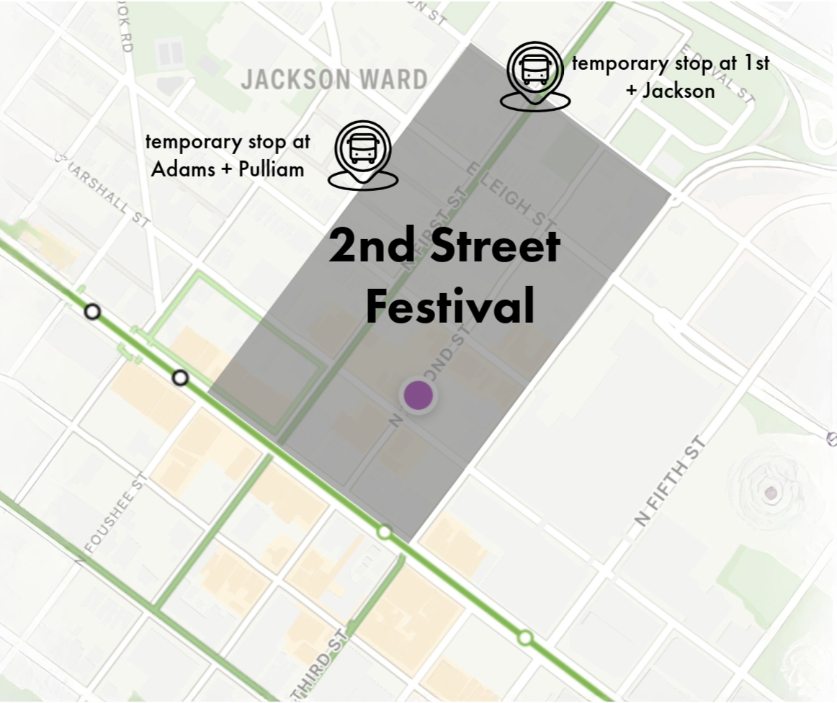

Routes 1, 2A/B/C, 3A/B/C, 50, and 87 will detour to avoid closures to 1st, 2nd, and Leigh Street.

Temporary Stops Added at Chamberlayne between Jackson + Buval, 1st + Jackson, and Adams + Pulliam.

Broad Street I-95 Bridge Replacement Closure

Routes 7A, 7B, 56, and 95 may detour. Broad Street is closed between 14th Street and 1yth street from Friday, 10/4, at 8 pm to Monday, 10/7, at 6 AM.

Detours:

Routes 7A, 7B, and 56 will detour on Main Street between 14th and 17th (eastbound) and via Grace street between 18th and 14th, (westbound)

