For Immediate Release
January 27, 2025
Michael Hurt
Mike.hurt@ridegrtc.com
804-474-9917

GRTC Launches Public Safety Officer and Public Safety Ambassador Program to Enhance Rider Experience and Security
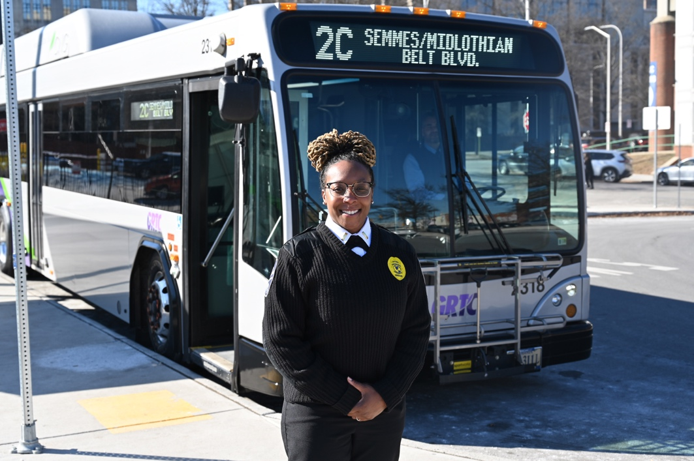
RICHMOND, VA – GRTC is proud to announce the launch of its new Public Safety Officer (PSO) and Public Safety Ambassador (PSA) programs, designed to enhance security, provide customer assistance, and foster a stronger sense of community throughout the transit system. These programs aim to create a safer, more welcoming environment for riders and staff while minimizing service disruptions.
Public Safety Officers will focus on maintaining a secure environment, deterring potential disruptions, and ensuring swift responses to incidents. Working closely with local law enforcement and community partners, they are equipped to address safety concerns proactively.
Public Safety Ambassadors will serve as a visible, customer-focused presence throughout the transit system, assisting passengers, answering questions, and addressing concerns. Both Public Safety Officers and Public Safety Ambassadors are trained in de-escalation techniques to promote a positive and safe transit experience for everyone.

GRTC CEO Sheryl Adams expressed her enthusiasm about the initiative, stating:
"Safety is our number one priority. The launch of the Public Safety Officer and Public Safety Ambassador programs is a significant step forward in enhancing the transit experience for both our staff and passengers across the GRTC network."
This initiative is part of GRTC’s ongoing commitment to improving safety, encouraging ridership, and ensuring reliable transit service throughout the region. The Public Safety Officer program officially launches on Monday, February 3, 2025. For more information, please visit ridegrtc.com.

###
GRTC’s mission is to connect people to opportunities by providing safe, sustainable, reliable, and equitable transportation.

